**Preliminary Recommendations**

**Description**

The goal of this project is to meet the needs of cost controlling and cost monitoring Budget and Actual expense in timeline basis from Andesit Project

**Purpose**

Since the complexity of Mining Project is excessively especially regarding cost controlling and cost monitoring, therefore Ametis will develop reliable and competence system fits with Project Needs especially for reporting to Management

**Project Scope:**

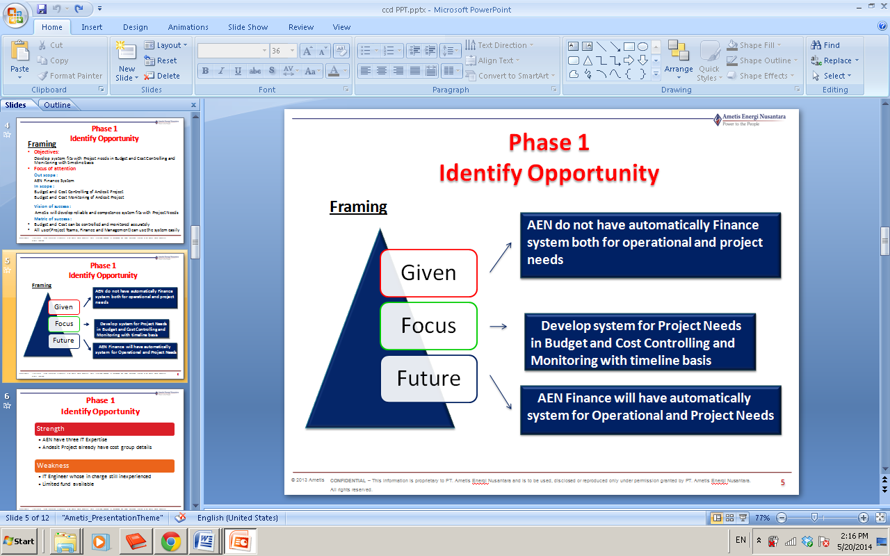

**Out scope:**

AEN Finance System

**In scope:**

Controlling and Monitoring Budget and Cost of Andesit Project

**Metric of success:**

* Management can generate report promptly and accurately
* Budget and Cost Transaction input can be done easily

**Project Authority:**

**Andesite Project Team**

* Able to propose for the project cost
* Inform all updated budget plan

**Andesit Project Manager**

* Able to change the budget plan and the timeline
* Able to generate report

**Finance Admin**

* Able to change the budget plan (based on information and approval from PM Andesit)
* Able to input all cost transaction (input, change and remove/delete)
* Verify project cost that is proposed by project team with the budget availability
* Able to generate report

**Finance Supervisor**

* Verify project cost that is proposed by project team with the budget availability
* Able to generate report

**Management & Director**

* Able to generate report

**Effort estimation**

**Resourcing/Person Days Needed**

|  |  |  |
| --- | --- | --- |
| **Position** | **Project Responsibilities** | **Est. Person Days** |
| Project Manager | Coordinate all team member and investigate the system | 1 |
| IT Expertise | Do all IT system | 1 |
| Finance Team | Record the Budget and Transaction  Do documentation for the project | 2 |
|  | **TOTAL PERSON DAYS** | **4** |

**Project Risks**

|  |  |  |  |  |  |
| --- | --- | --- | --- | --- | --- |
| **Risk Name** | **Description** | **Impact on Project**  (In Cost, Deliverables, Schedule, etc) | **Severity**  **(H,M,L)** | **Probability**  **(H,M,L)** | **Risk Rating**  *see note |
|  |  |  |  |  |  |
|  |  |  |  |  |  |
|  |  |  |  |  |  |
|  |  |  |  |  |  |